Comparisons with Memorials around the World

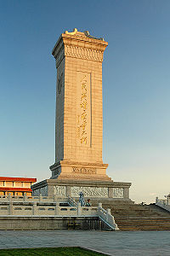
Most memorials contain monuments, such as stone columns or statues. Most of these sometimes have names upon them or words to commemorate people. These are always appropriate in a memorial for the Holocaust because they help people to remember events and people, like the Wall of Names in the Memorial de la Shoah in France. Some memorials are like museums and in a Holocaust memorial; it can be a good idea to have items from that period in time. For example, some helmets from the Great War in a WW1 memorial or gas masks for WW2. In this case, for a Holocaust memorial, it could include number tags, Jewish artefacts or sometimes clothes.

Sometimes, inappropriate things can be found in museums and memorials. I found this picture of a statue of some sort called Yad Vashem in Jerusalem.
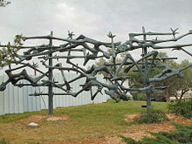
When I studied it closer I realised what it resembles. It appears to be thin dead people entangled in a pile. I don’t like the idea of something like this there. It is not necessarily disrespectful, but quite alarming and I don’t feel it to be a good idea for going in a memorial.

In the Memorial de la Shoah, there are similar items to this on display. These stone engravings also show scenes from the Holocaust, such as women being shot. I feel the same way about these as with the item in Yad Vashem.

An Appropriate Memorial

- To have an appropriate Holocaust memorial, you have to only think of remembering the people for who they were. A plaque with names and dates on it is a good way of portraying the scale of a death toll or important people in a war.
- Of course, there is no limit on how beautiful you can make a building. A nice building is always good for a memorial.
- Artefacts are a good idea for a Holocaust memorial because it can motivate and interest people. Learning is a key part of visiting museums as such, so this is good initiative.
- There mustn’t be insulting or disturbing things in a respectable Memorial so this must be taken into mind.
- Finally, it is a good idea to organise the memorial well and to give appropriate names, sections etc.

