BEVERLEY  JOINT  SIXTH |  | 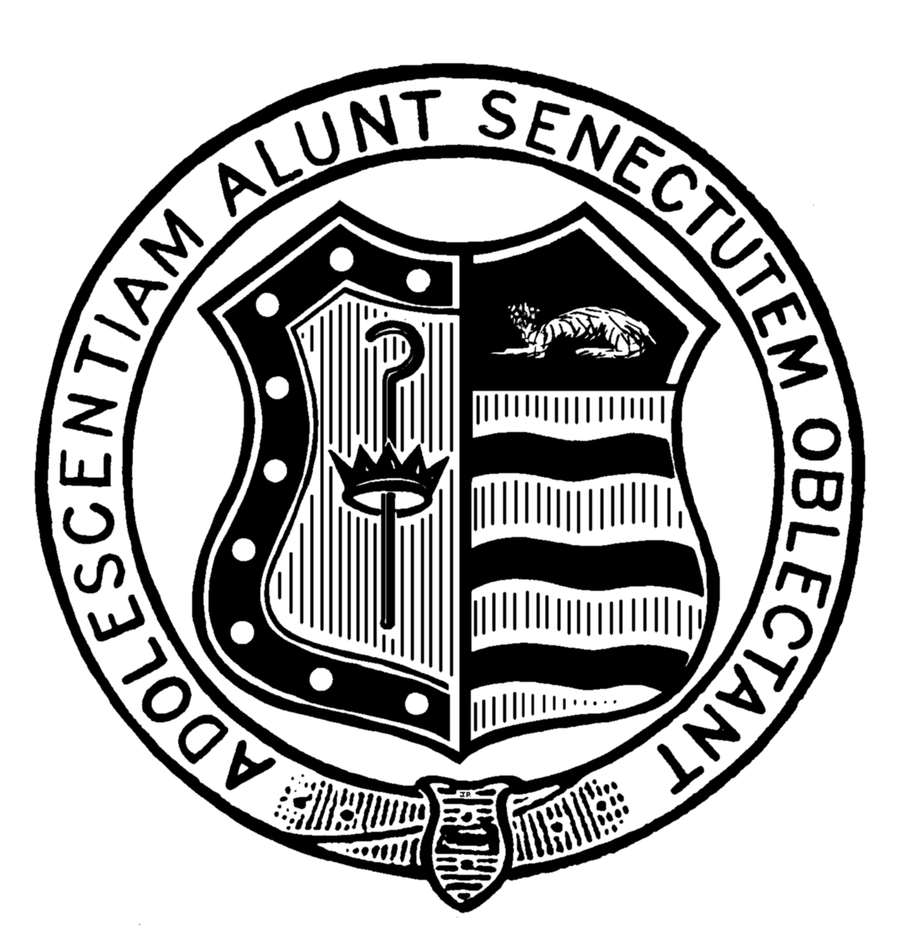    SKILLS REQUIRED 2013  Good communication skills (written and/or oral)  The ability to work independently and co-operatively in groups  The ability to receive and present opposing arguments in a balanced manner.  Researching and information accessing skills.  THE COURSE  Sociology is a popular and well established academic subject. The course involves the study of several issues that comprise a total of six modules. Issues include: Families and Households, Mass media, Education, Religion, Crime and Deviance, Stratification and Differentiation, Sociological Theory and Methods.  Concepts such as social order, social control, conflict and consensus are investigated during the course of each issue. Theoretical perspectives include Functionalism Marxism and Feminism. Two modules are examined during the course of Y12, these form the AS qualification. The remaining two modules are studied in Y13 and make up a full A level.  CAREER POSSIBILITIES  On completion of the course students can progress to higher education either to study Sociology as a single honours option or to combine it with other subjects of interest. A level sociology is a great opportunity to get to grips with the social theory that would be involved in any area or social sciences degree. Many sociologists enter the Civil and Public Services, whilst almost 25% gain employment in the private sector, quite often in the areas of Personnel Management and Advertising. Many of the country’s leading Media and Journalistic figures have a sociological background. The following information is taken from “What do Sociology graduates do?”  Admin & operational Management, Sales, Marketing, Buying, Financial, Information, Library, Museum work, Health & Social Welfare, Teaching.  GCSE PROFILE  Students who wish to study this subject will have achieved a minimum of 5 A* - C grades at GCSE, including English

